Tableau : Introduction

**Introduction:**

The landscape of Airbnb rentals in New York City presents a diverse array of insights when examined through the lens of data visualization. The following report leverages data scraped from Airbnb as of December 5, 2021, provided by Inside Airbnb, to uncover patterns and correlations within the market. Through an analysis of various factors such as average prices, room types, booking status, and cancellations, we aim to unearth strategic insights that can guide investment and operational decisions for stakeholders in the Airbnb ecosystem.

Question 1. 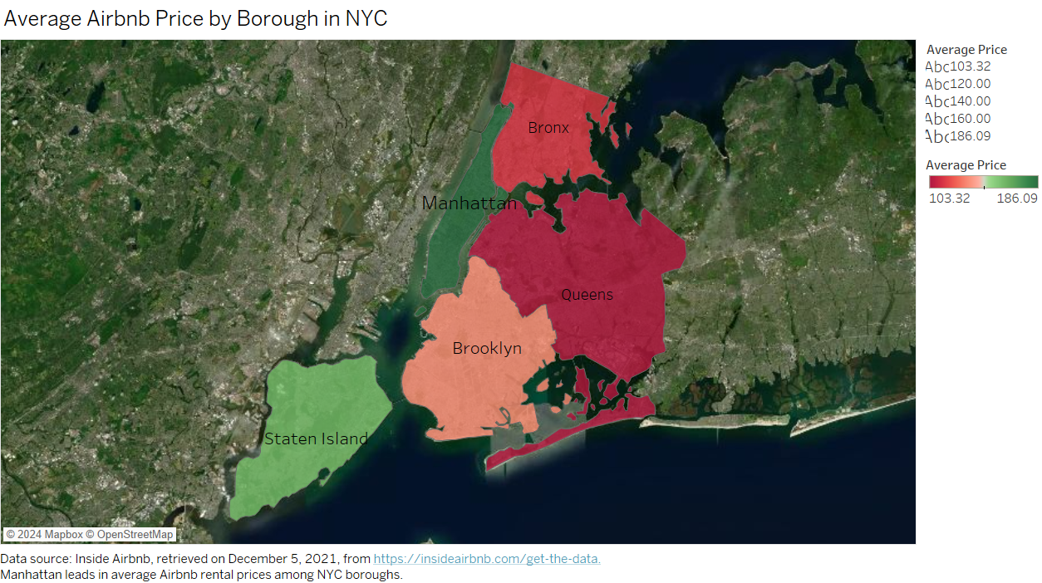

Interpretation:

This map visualization displays the average Airbnb rental prices by borough in New York City, highlighting Manhattan as the most expensive borough with an average price of $186.09 per day. In contrast, Queens and the Bronx are on the more affordable end, with averages of $103.32 and $113.08, respectively. This distribution suggests a correlation between price and the perceived desirability or demand for accommodations in different boroughs.

Question 2. 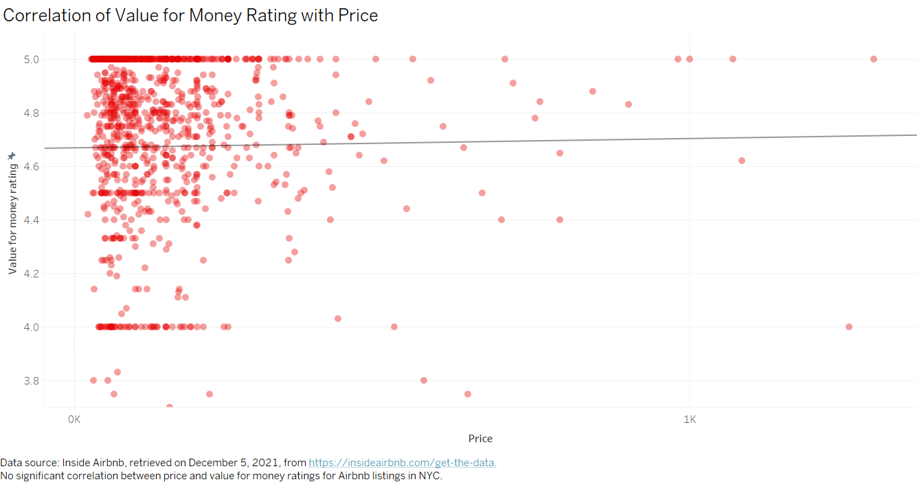

Interpretation:

(a) The scatter plot illustrates a lack of significant correlation between the price of Airbnb listings and their respective value for money ratings, as indicated by a near-zero slope of the trend line and a high p-value (0.748). This implies that guests do not necessarily perceive higher-priced properties as offering better or worse value for money. The R-squared value is also extremely low (0.0001035), which means that the price variable, as it is, does not explain the variance in the value for money ratings. This suggests that guests consider other factors beyond price when rating the value for money of a property. With such findings, Airbnb hosts should consider that their pricing strategy might not directly influence guests' perceived value for money, and they may need to focus on other aspects of their service or offering.

(b) 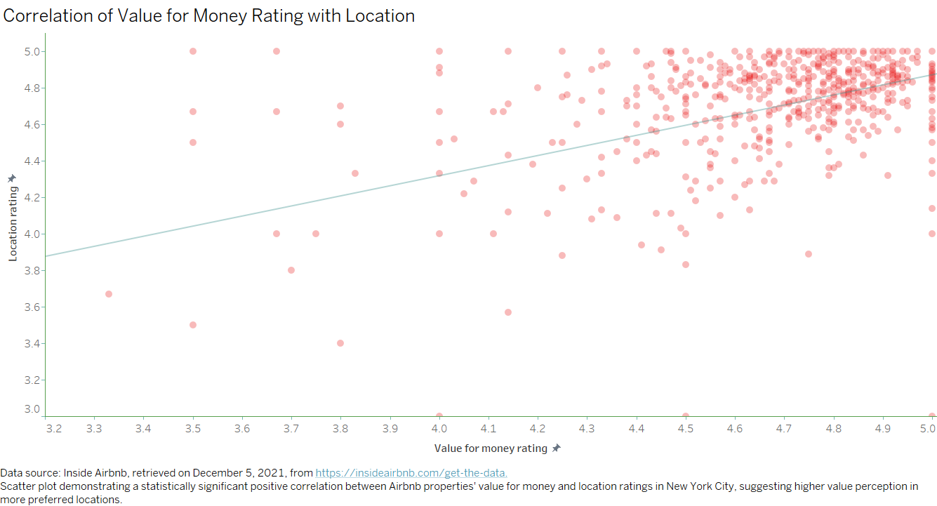

Interpretation:

The chart reveals a notable positive correlation between the 'Value for Money' rating and the 'Location' rating of Airbnb properties. The trend line indicates that properties with higher value for money ratings also tend to have higher location ratings. With a p-value of less than 0.0001, this relationship is statistically significant. The slope coefficient of 0.553 suggests that for every one unit increase in the value for money rating, the location rating increases by approximately 0.553 units. This model, which is based on 518 observations, explains 27.5% of the variance in location ratings (R-squared = 0.275459), which is a substantial amount considering the multitude of factors that can influence guest ratings. The implication for Airbnb hosts is clear: improving perceived value for money could also enhance perceptions of the property's location, potentially affecting pricing and booking strategies.

Question 3. 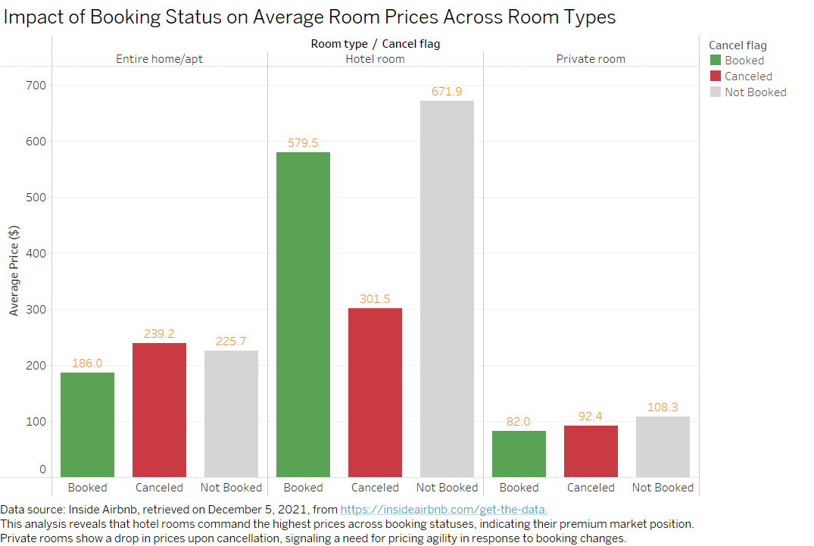

Interpretation:

The chart above offers a strategic view into how the average room prices vary by booking status and room type. Notably, hotel rooms exhibit a significant price premium, especially when booked, which suggests a strong market for high-value listings. 'Canceled' and 'Not Booked' statuses in private rooms highlight a pricing challenge, possibly indicating the need for more competitive pricing strategies to ensure these listings remain attractive to potential guests.

Question 4.

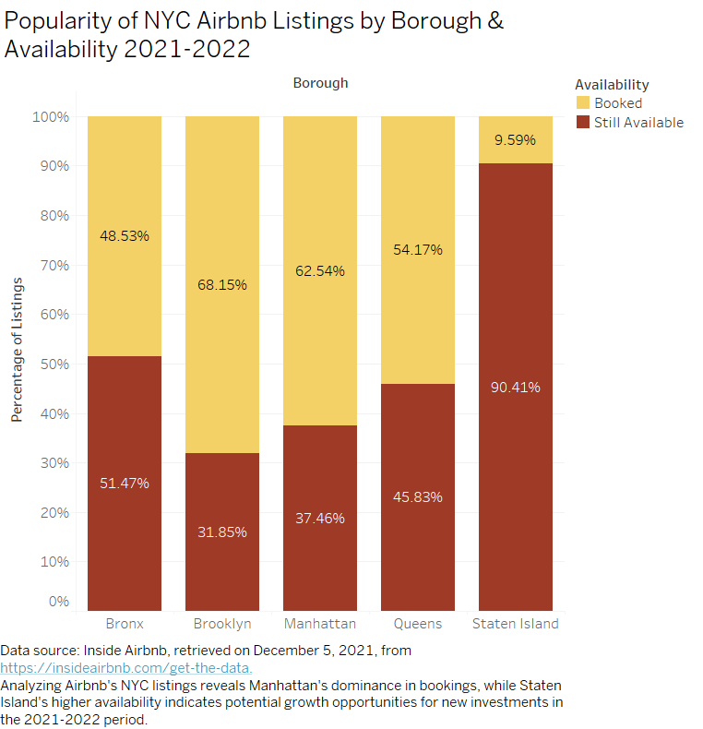

Interpretation:

This chart offers a comprehensive view of Airbnb listing availability across NYC boroughs for 2021-2022, presenting a stark contrast in popularity and occupancy rates. The high percentage of available listings in Staten Island suggests a lower demand compared to other boroughs, potentially indicating a market opportunity for new investors or a need for targeted marketing strategies to increase bookings. On the other hand, the substantial percentage of booked listings in Manhattan reflects its enduring appeal and consistent demand, affirming its status as a prime location for investment.

Question 5. 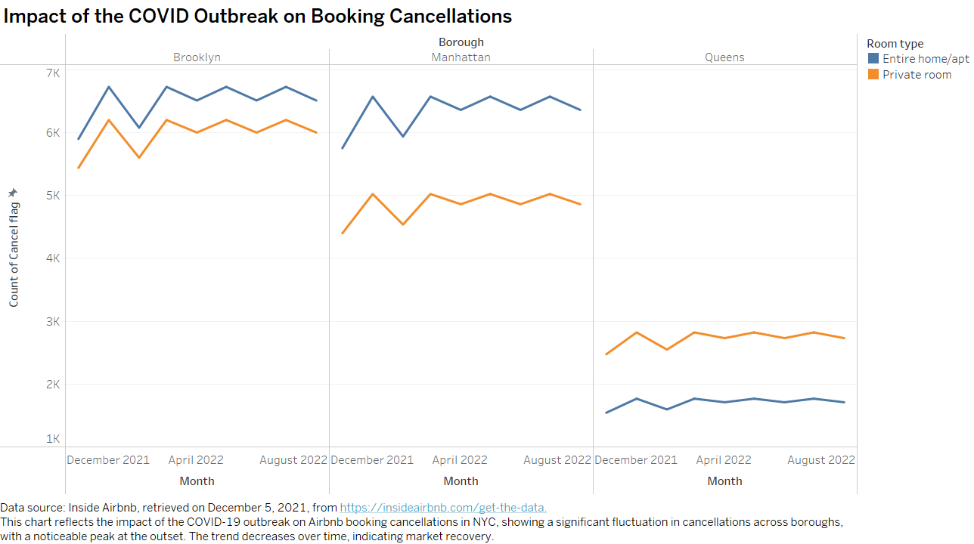

Interpretation:

The chart illustrates a comparative analysis of booking cancellations in Brooklyn, Manhattan, and Queens following the November 2021 COVID outbreak. It becomes evident that while cancellations spiked initially, there is a subsequent decline over the following months, showcasing signs of market resilience. The data also highlights that Private rooms in Brooklyn have a more pronounced decrease, suggesting a shift in consumer preference or perceived safety in shared spaces. Such insights are crucial for Airbnb's strategic planning to mitigate future disruptions and understand evolving consumer behaviors.

Question 6. : 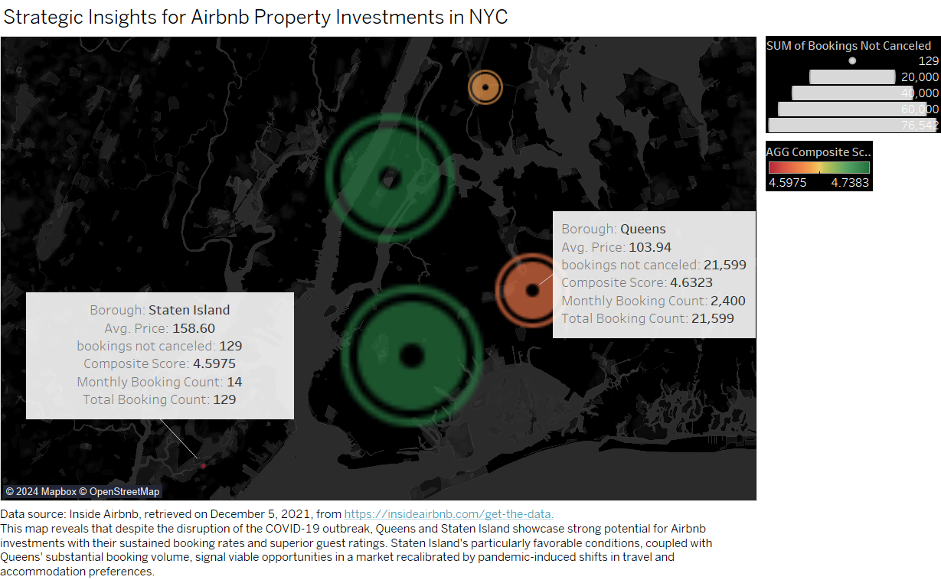

Interpretation:

In the quest to pinpoint prime Airbnb investment locations across NYC, this map elucidates areas with considerable booking retention and exceptional guest satisfaction scores. Particularly, Queens presents itself as a prolific borough, reflecting resilience with a high volume of bookings sustained through the pandemic. The notable concentration of positive guest experiences, mirrored in its composite score, underscores Queens as a thriving rental market. Conversely, Staten Island emerges as an unexpected beacon of investment potential, demonstrated by low cancellation rates and favorable guest feedback. These insights are critical in a post-COVID landscape, where traveler preferences have likely shifted towards boroughs perceived as safer and offering better value, a sentiment possibly reflected in the 'NA' booking statuses, which indicate untapped potential. The data suggests a strategic pivot towards these boroughs could capitalize on emerging trends for long-term rental success in a recovering market.

**Conclusion:**

The series of analyses underscore the nuanced dynamics of New York City's Airbnb market. Manhattan's high average prices reflect its status as a lucrative but competitive borough, while Queens' and Staten Island's data reveal untapped potential in terms of both value for money and lower cancellation rates. The insights gained from the relationship between pricing, value, location, and booking statuses shed light on the importance of strategic positioning and adaptability within the market. Furthermore, the fluctuations in booking cancellations during the COVID-19 pandemic highlight the industry's resilience and the need for ongoing analysis to navigate future market shifts effectively. For an investor or host in the Airbnb market, these visualizations underscore the significance of location choice, room type differentiation, and dynamic pricing strategies to maximize occupancy and profitability in a post-pandemic era.

----------------------------------------------------------------------------------------------------------------------------------